PRESS RELEASE

COMMUNICATIONS AND MEDIA TEAM OF THE 43RD ASEAN SUMMIT 2023

No.26/SP/TKM-ASEAN2023/ENG/9/2023

President Inspects ASEAN Summit 2023 Venue

Jakarta, September 01, 2023 – President Joko Widodo (Jokowi) has personally inspected the preparations of the venue for the 43rd ASEAN Summit 2023 at the Jakarta Convention Center (JCC), Senayan, Jakarta, Friday (09/01/2023).

President Jokowi arrived at the JCC at around 09:30 WIB accompanied by a number of Ministers of the Onward Indonesia Cabinet, including Minister of Foreign Affairs Retno L Marsudi, Minister of Public Works and Public Housing (PUPR) Basuki Hadimuljono, and Minister of State-owned Enterprises Erick Thohir.

At JCC, the President and his entourage visited a number of halls, including the Media Center located in Hall B of JCC. In addition, President Jokowi also visited the main hall that will be used for the ASEAN Summit meeting at the JCC Plenary Hall.

The Head of State explained that preparations for the 43rd ASEAN Summit, which will be held on September 5-7, 2023 are almost completed. Some minor improvements were still needed but these will be handled immediately by the committee.

"The flag is not high enough, that’s it, minor correction," he said.

President Jokowi has also received confirmation of the heads of state who will be attending the event, which is currently being handled by the Ministry of Foreign Affairs.

He also added that this year’s ASEAN Summit carries many important agendas, one of which will focus on the economic sector in the ASEAN region.

"There are plenty (of agendas), but the focus is on the economy. On the growth of ASEAN as a center of economic growth," he said.

After leaving the interview session, President Jokowi and his entourage continued to inspect other locations. (Andi Firdaus/Elvira Inda Sari)

***

For more information, please contact:
Director General of Public Information and Communications of the Ministry of Communications and Informatics – Usman Kansong (0816785320).

Get more information at http://asean2023.id, https://infopublik.id/kategori/asean-2023, and https://indonesia.go.id/kategori/ragam-asean-2023

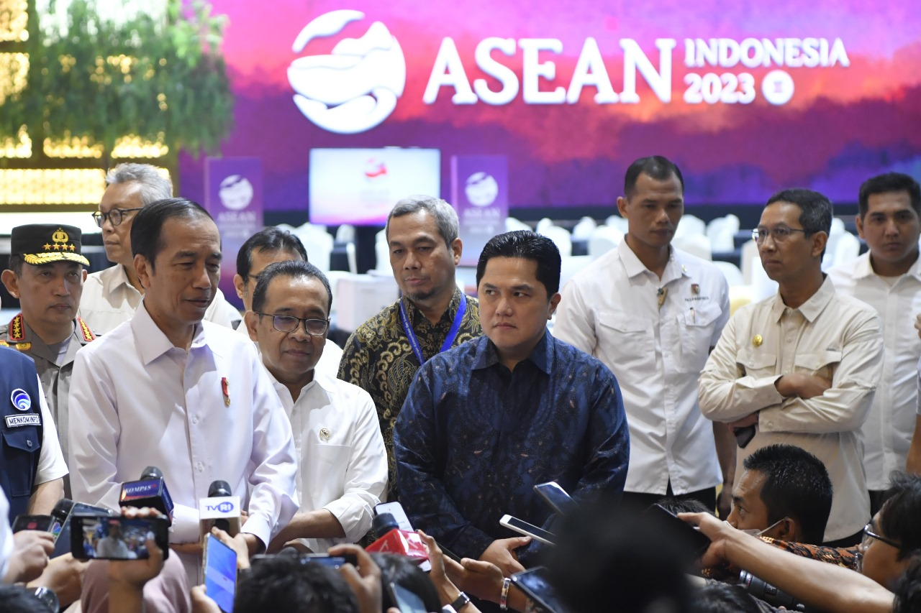

President Joko Widodo (second left) accompanied by Minister of State Secretary Pratikno (third left), Minister of State-Owned Enterprises Erick Thohir (Fourth right), and a number of officials give statements to the journalists during a visit to the media center of the 43rd ASEAN Summit at the JCC, Jakarta, Friday (09/01/2023). Media Center of the 2023 ASEAN Summit/ Zabur Karuru/foc.

